Quantum k-Nearest Neighbors (QkNN)

1. Problem
The k-Nearest Neighbors (kNN) algorithm is a classical distance-based method used for classification and regression. Given a query data point, kNN identifies the k closest data points in the training set and predicts the label based on majority voting (classification) or averaging (regression).
Classically, kNN becomes computationally expensive for large datasets and high-dimensional data. Quantum k-Nearest Neighbors (QkNN) aims to accelerate distance or similarity computations using quantum subroutines.

2. Intuition
QkNN leverages quantum mechanics to estimate distances more efficiently:
- Classical data vectors are encoded into quantum states
- Quantum circuits compute inner products or similarities
- Measurement probabilities encode distance information
- Classical post-processing selects the k nearest neighbors
The potential advantage comes from handling high-dimensional data using quantum parallelism.

3. Circuit / Algorithm Structure
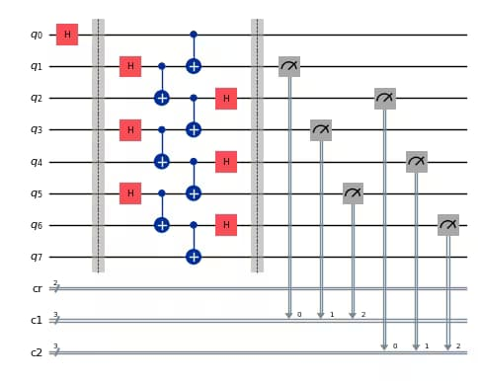
A typical QkNN workflow consists of:
- Data Encoding
Encode classical vectors into quantum states (amplitude encoding).
- Distance Estimation
Use quantum circuits such as the swap test to compute similarities.
- Measurement
Extract distance-related probabilities.
- Classical Decision Rule
Select k nearest neighbors and predict the output.

4. Simple Math Involved
- Inner product similarity: [ x | y ]
- Euclidean distance: [ |x - y|^2 = 2 - 2x | y ]
- Swap test probability: [ P(0) = ]

5. Python Code (Quantum kNN – Qiskit)
import numpy as np
from qiskit import QuantumCircuit
from qiskit.primitives import Sampler

def normalize(v):
return v / np.linalg.norm(v)
def quantum_distance(vec1, vec2, shots=1024):
qc = QuantumCircuit(3)
qc.h(0)
qc.initialize(vec1, 1)
qc.initialize(vec2, 2)
qc.cswap(0, 1, 2)

qc.h(0)
qc.measure_all()

sampler = Sampler()
result = sampler.run(qc, shots=shots).result()
p0 = result.quasi_dists[0].get("000", 0)
overlap = 2 * p0 - 1
distance = np.sqrt(2 - 2 * overlap)

return distance

X_train = [
normalize(np.array([1.0, 0.4])),
normalize(np.array([0.2, 0.9])),
normalize(np.array([0.9, 0.3])),
]

y_train = [0, 1, 0] # class labels

x_query = normalize(np.array([1.0, 0.5]))

distances = []
for x in X_train:
d = quantum_distance(x_query, x)
distances.append(d)

k = 2

nearest_indices = np.argsort(distances)[:k]
nearest_labels = [y_train[i] for i in nearest_indices]
prediction = max(set(nearest_labels), key=nearest_labels.count)

print("Quantum distances:", distances)
print("Nearest indices:", nearest_indices)
print("Nearest labels:", nearest_labels)
print("Predicted class:", prediction)

6. Where the Algorithm Is Useful
- High-dimensional classification
- Similarity search
- Recommendation systems
- Pattern recognition

7. Limitations
- Requires efficient quantum data encoding
- QRAM assumptions are strong
- Noise affects distance estimation
- No practical quantum advantage yet

8. Comparison with Classical kNN
- Distance computation: Quantum estimates inner products faster in high dimensions
- Data access: Classical RAM vs. quantum QRAM
- Scalability: Classical kNN is mature; QkNN is experimental
- Output: Both return classical labels

9. One-Sentence Summary
Quantum k-Nearest Neighbors uses quantum distance estimation techniques to accelerate similarity-based learning tasks.

